What Are Non-Classroom Dollars Really?

Fact Sheet: What these dollars mean for (DISTRICT NAME) and the (NUMBER OF STUDENTS) children and their families that we serve within Legislative District (LD NUMBER)
Prepared and Presented by: (YOUR NAME, TITLE, CONTACT INFO)
- Our district employs (NUMBER OF EMPLOYEES) people within (LD NUMBER), of which (NUMBER OF NON-CLASSROOM EMPLOYEES) would be affected by these cuts, even if they have a direct roll with students.
  - As an example, (STUDENT-FOCUSED POSITION) could be hurt

- What this would mean for Legislative District (LD NUMBER)
  - (STUDENT SERVICE THAT WOULD BE HURT)
  - Our district (ECONOMIC/SOCIAL BENEFIT YOU BRING TO THE COMMUNITY), and this proposal would negatively impact that
  - Our community would lose (AMOUNT OF MONEY REMOVED FROM DISTRICT) in local investment

- Learning doesn’t just happen in the classroom, we need to make sure we’re supporting the whole child. The staff helping our teachers and students ensures that.
  - (SHARE A PERSONAL STORY FROM AN EMPLOYEE, PARENT, FORMER STUDENT, ETC)
  - Example : http://www.cbsnews.com/videos/high-school-janitor-goes-above-and-beyond/
Action Requested:
Please oppose any budget effort that harms our schools’ ability to educate students

Definitions:
Classroom dollars
- Classroom personnel―Teachers, teachers’ aides, substitute teachers, graders, contracted instructional services, athletic coaches
- General instructional supplies―Paper, pencils, crayons, etc.
- Instructional aids―Textbooks, workbooks, instructional kits, instructional computer software, films, etc. Internet access for instruction is also included in classroom spending.
- Activities―Field trips, athletics, as well as activities such as choir and band
- Tuition―Paid to out-of-state and private institutions

Non-classroom dollars
- Administration― Salaries and benefits for superintendents; principals; business managers; clerical & accounting staff, payroll, purchasing, warehousing, printing, human resource activities and administrative technology services; other related and governing board costs
- Plant operation and maintenance― Salaries, benefits, and other costs related to equipment repair, building maintenance, custodial services, groundskeeping and security; as well as costs for heating, cooling and property insurance
- Food service― Salaries, benefits, food supplies, and other costs related to preparing, transporting, and serving meals and snacks
- Transportation― Salaries, benefits, and other costs related to transporting students to and from school as well as maintaining buses
- Student support services― Salaries and benefits for attendance clerks, social workers, counselors, nurses, audiologists, and speech pathologists and other costs related to these support services to students
- Instruction support services― Salaries and benefits of curriculum directors, special education directors, teacher trainers, librarians, media specialists, and instruction-related IT staff & other costs related to assisting instructional staff in the delivery of instruction

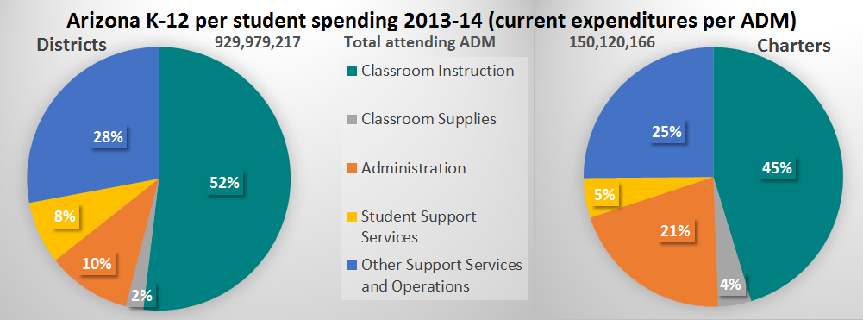

Definitions adapted from U.S. Department of Education’s National Center for Education Statistics (NCES); graph data from Arizona Auditor General’s Report

